

Dear Parent(s),
Welcome to fourth grade!!! Thank you for sharing your child with me for the upcoming school year. This is my 40th year of teaching. I have taught 30 years in elementary (K, 1, 3, and 4) and I have also taught 10 years in middle school (6, 7 and 8 math). I have two grown sons, two dogs, and a cat. This year every student will have the opportunity to showcase something special on the fourth grade “Text Features” bulletin board in the hallway. This is their first project. It will be due: Monday, September 14, 2026. It will also be part of their grade, so please bring as much creativity as possible into it.

I just wanted to communicate my classroom expectations for the school year. I use CHAMPs throughout the day. C- (conversation the student should be having), H- (help if they need it), A- (activity), M-(movement), P-(participation), s- (success for all students). I will go over these rules and procedures with them. Students “caught” doing the right thing will receive Dojo points. I will be sending out details on how to access your child’s information. They can also be deducted points if needed.

Discipline procedures: The following charts will give a detailed description of my expectations. Children will receive a warning, then think time, then they will call a parent if they are not able to follow the classroom rules. If a parent is called, a paper will go home that can help restore our relationship with each other and God. Also, I have hand signals that the students must use in order to have permission to get out of their seats.

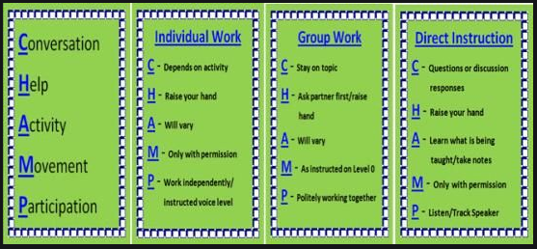

Voice Level(s): 4-outside/recess
3-presentations
2-group work
1-partner work
0-solo work/teacher direct instruction.

Homework procedures/Agenda: Homework is posted weekly on SMM web page. Students are expected to read a minimum of 20 minutes per night. They will be having a vocabulary/spelling test each Friday. They will also be tested (WEEKLY) on their math facts. 1st nine weeks (addition) 2nd nine weeks (subtraction), 3rd nine weeks (multiplication), and 4th nine weeks (division). So please study your facts. 🙂NO PAPERS WILL GO HOME FOR HOMEWORK. IT IS THE STUDENT’S/PARENT’S RESPONSIBILITY TO READ THE WEEKLY NEWSLETTER.

Dismissal procedures: Your student should be out in the parking lot by 3:20. At that time we will look for your car. Students will give me a fist bump when they see the person picking them up. Students are not allowed to walk through the parking lot when they see you for safety reasons.

Mass/Confession: Our class will have the opportunity to attend 8:00 a.m. mass on Mondays and Fridays. Feel free to join us or attend mass any time as posted in the front of the school. Students will receive a conduct grade for participation during mass and confession.

Rewards/Celebrations: As stated earlier, students caught following the CHAMPs expectations will receive Dojo points. He/she will also receive points for showing virtuous behavior. Finally, they are also receiving group points in the classroom. Every Friday the group with the most points will receive a special snack. Please make sure you join our classroom dojo. If you need to contact me, please see my phone number below. I don’t read emails and dojo communication every day. I will see your text first.
Thank you,
Mrs. Morgan 😊

If you have any questions or concerns, the best way to contact me is through a text. My phone number is: (316) 347-4529.

